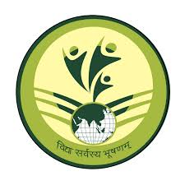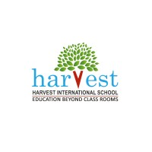 Saysa 2024

Documentation for Eco – wars

Tools used: -

1. Python language
2. Pygame library
3. Moviepy library
4. Canva
5. Pixel art

Brief Introduction to Eco-Warriors:

Eco-Warriors is a single player platformer game, where the main central theme and idea is to save the world. We used the theme of SDGs where the player fulfils SDG 13,14 AND 15 to design the topic of the game.

Level 1: -

The player has to kill two enemies in order to get coins and go to the next level, he collects a magic potion which can help him breath under the water which will help him in the next level.

Level 2: -

The player has to pick up garbage thrown under water by the people. Each piece of trash the player picks up he gets one coin to move to the next level. after collecting the all trash, he gains a powerup and is confident to go to the final level.

Level 3 (Final level): -

The player has now come to the final level where he has to show what all he has done throughout the game. He faces three bosses each having their own unique attacks. The player has to show his skill and defeat all the three bosses. Each boss defeated gives two coins. After all bosses are defeated he has successfully saved the world and now is called the hero of the world.

Motive of the game: -

After playing eco-wars the player will understand the importance of following all the SDGs and will get motivated to save the environment. He will develop affection towards cleaning his environment.